Answer: Actually in the original spatial average method it requires several multiple pulses and gradients, as Referee A indicated. In our experiment, we wrote a program for searching a unitary operator. After adding this operator and a gradient operator on the thermal equilibrium state, if the fidelity between the final state and |0000> is higher than our pre-set value, we will pack this operator into a shape pulse, i.e., GRAPE pulse. Otherwise, we will perturb the unitary operator through the GRAPE algorithm to obtain a new one.

Therefore, the unitary transformation depends on the returned result of the searching program. In this experiment, the unitary transformation is shown in the attachment u.mat, and the state prior to the application of the gradient is shown in output.mat. After a gradient pulse to destroy coherence, the diagonal elements of the final state is

[1.5116, -0.0982, -0.1203, -0.1085, -0.0997, -0.0721, -0.1115, -0.0981, -0.1062, -0.1361, -0.0832, -0.0967, -0.0516, -0.1124, -0.0811, -0.1358].

If ignoring the identity matrix, the final state is very similar to |0000>, as shown in bar.jpg.

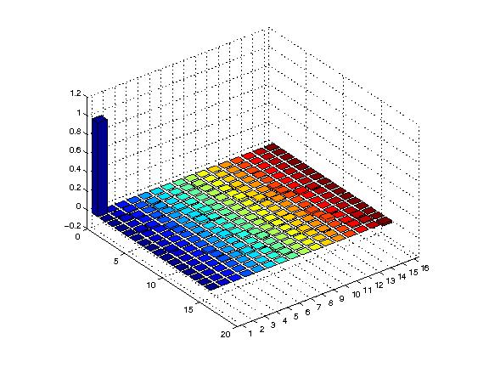

We used not only the small flip-angle probe pulse to detect the signal, but also use 32 designed readout pulses [PRA 81, 022308 (2010)] to examine the diagonal elements of the PPS. However, in order to compare the spectra of the input state and output state clearly as shown in Fig. 3, we just plot the spectrum of |0000> applying a small flip-angle probe pulse.